G StreetTrains
July, 2019
bnobob@hotmail.com

= ===========================================================

This is one of two battery operated Royal Blue with Locomotive and Coal Tender. The one in this picture includes the box and has power as the light works. I can't get the train to move. The other one in the next picture is in rougher shape as the power source had corroded batteries and only has the Styrofoam.

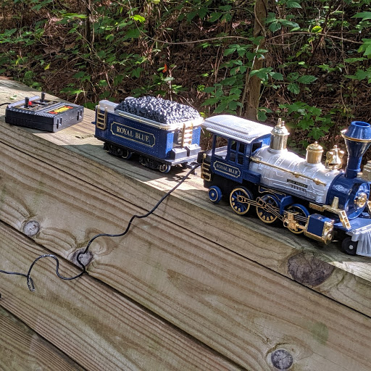

Here is the second battery operated Royal Blue with Locomotive and Coal Tender.
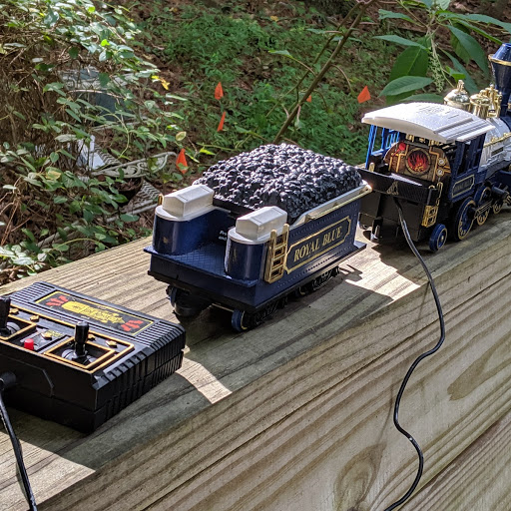

Bachman Big Haulers D&RGW Rio Grande #1638 Gondola G Scale

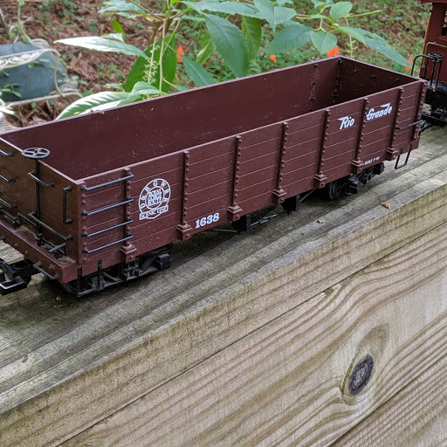

Bachmann Train BIG Haulers Baltimore & Ohio #1525 Flat Car G Scale / G Gauge
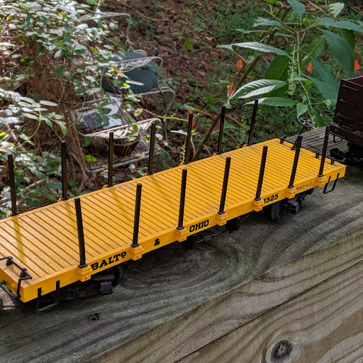

Bachmann 96202 G Scale Gandy Dancer Hand Car
However car is missing the "accessories".
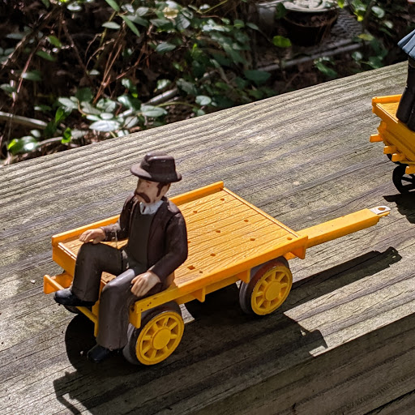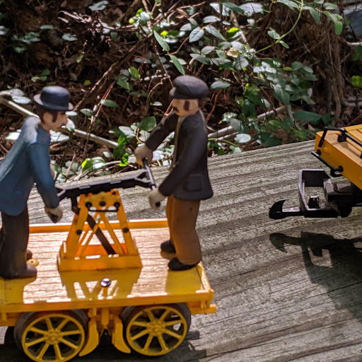

Royal Blue Complete Ready-to-run Train Set "G" Scale
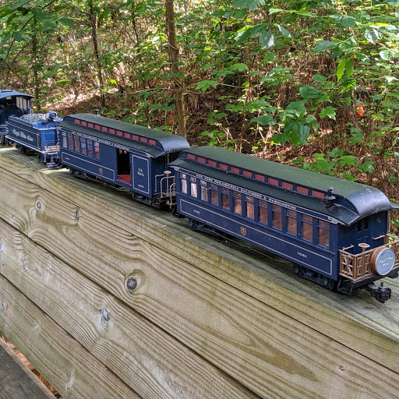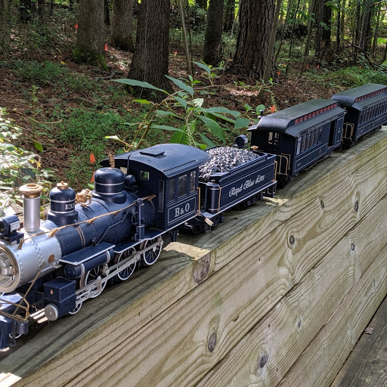

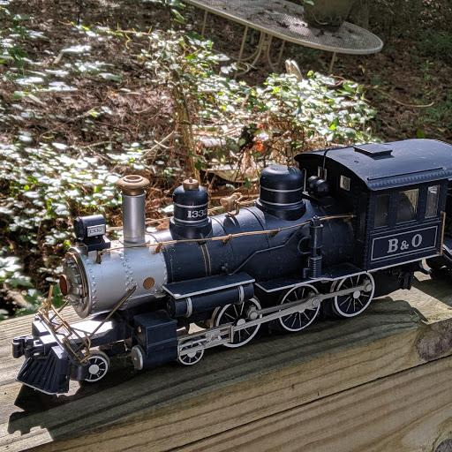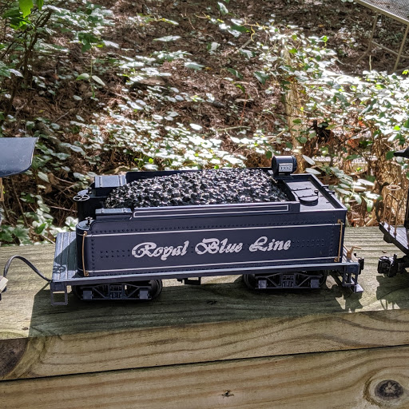

Bachmann's Big Hauler complete set
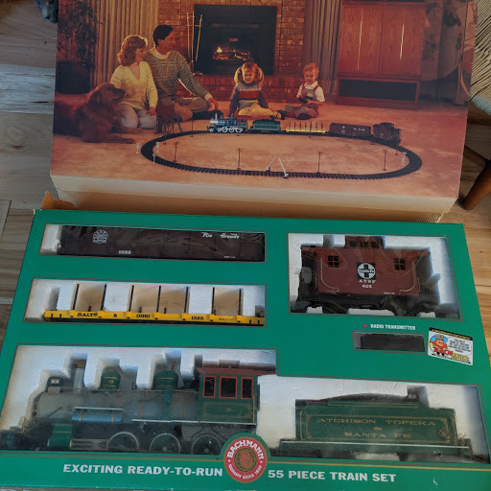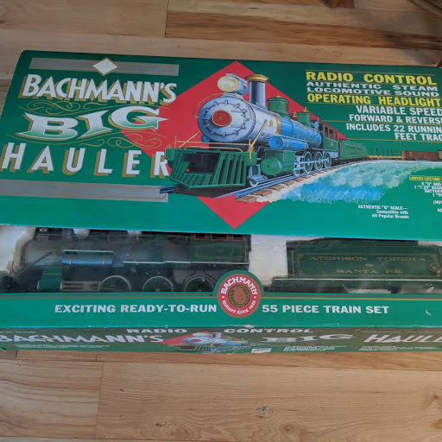

These models pictured have been opened, but never assembled. I double checked to make sure all was there and discovered the contents had never been disturbed. First buyer of this offer will get an additional model at no charge.
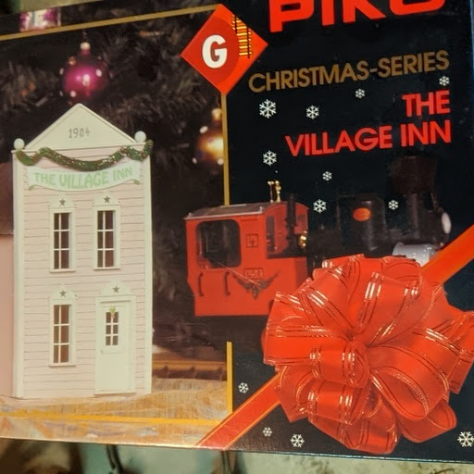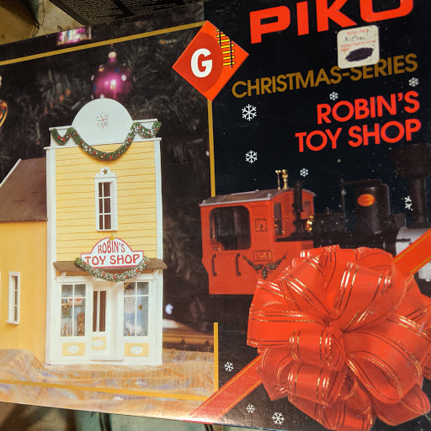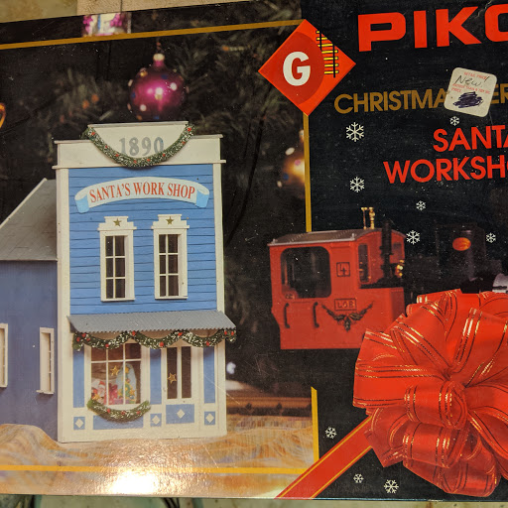

That's it for the G gauge. Thanks again.

