The EAST COAST CHAMPION
July 2007
2007

De 2006
OBITUARY
Chapter member WILLIAM (Bill) H. HURST, 90, of Port St. John, FL passed away on Monday, June 25, 2007 at his residence. He was a former resident of Lafayette, IN. until 1985. Born August 2, 1916 and a graduate of Battle Ground High School. He married Leah Robinson in 1937 and she preceded him in death in 1981. His present wife, Janice Bennett Hurst, survives.
Bill worked as a brakeman and then as a conductor for the Monon RR. He was a collector of Monon memorabilia and built Monon model trains. For several years he belonged to the local Florida East Coast/NRHS Chapter.
For the memorial service in Indiana, please contact Soller-Baker Funeral Home, 400 Twyckenham Blvd., Lafayette, IN at (765) 474-1111. Interment will take place at Tippecanoe Memorial Gardens in West Lafayette, IN.

PRESIDENT’S MEMO TO STOCKHOLDERS
A while back (3 yrs or so) I posted a little anecdote about Special Order books which were used on the ERIE/EL to notify train crews of conditions on the railroad pertaining to slow orders, work areas, etc. These books were prominently displayed at any terminal on the Division where train crews reported for duty. When I worked as an operator on the Mahoning Division, one of my duties was to line up all the stations - Leavittsburg, Niles, Kent, Sharon, Breir Hill, etc. and read off the order to be copied by the operator at that place and put in the book. The crews coming on duty would read & sign in to show they were aware of the orders in effect. My story told how I'd failed to read the book & nearly got into a wreck because NOBODY ELSE on the crew had either. I saw the story archived in the ELT&HS site and re-read it and a follow-up incident came to mind. By 1964 -67, I was working in Binghamton, NY which consisted mostly of yard jobs so there wasn't much call to look at the special orders since you never left the yard. The ONLY exception to this was the Cortland/Homer local and that job was held by very senior men so I got out of the habit of 'looking at the Special Order book'. This attracted the attention of the dreaded Sammy Miller (RFE). His secretary, Joyce, told me "Sammy is going around to all the yard offices seeing if you sign the special order books, so look out". I thanked her for wising me up to the Gestapo being on my trail & racked my brain for what to do without confronting Miller. I finally began going around to all the yard offices and the passenger station myself but doing so at 2 or 3 AM when Sammy was in his beddie-bye dreaming of torturing engine crews. I'd open the books and page back a ways and then begin looking for where someone had left a space or 2 in the lines where you signed the book for each order. I usually found 12 or 14 lines deep a space and there put - WALTER E. SMITH, ENGINEER. Then I'd work my way forward to the most recent order, signing wherever there was a space. Since Sammy took a while to figure out what happened, I guess he wasn't sure if HE slipped up and missed my signature so it all passed over (like the Angel of Death), but it didn't improve his disposition.
Along about this time I went to Florida and signed on with the (then-new) Auto-Train. I felt like one of the men who escaped from Bataan or Corregidor and knew that my friends were left behind to suffer torture by the Japanese army (Sammy).

Regards to all
Walter E. Smith

MINUTES OF THE JUNE 2007 MEETING

Chapter President Walter Smith called the meeting to order at 7:05 PM on June 11, 2007. The chapter had two guests; Earl Baer of Titusville who was our guest speaker and Wil Harkins, an NRHS member from Arlington Virginia.

Treasurer’s Report –Bob Selle presented the treasurers report. Don Pirson moved to approve the report. Jim Carter seconded the motion. The motion passed.

Approval of Minutes –The Secretary called for additions, corrections or comments to the May minutes as published in the “Champion”. Dave Klein offered a correction that it was he that had purchased the three volume set, Detroit Electric and that Tom Hammond had won the raffle and had selected the book Texas Electrics and Bob Robinson has selected a book on the Monon. The proceedings were interrupted delivering copies of the Brevard Historical Commission Quarterly. No motion was made or vote taken to accept the May minutes.

Old Business:
- Field trips: The Central Florida Chapter is also sponsoring a “Forgotten Right-of-Way Tour”. This tour will be a bus trip leaving the CFC chapter museum in Winter Garden at 8:30 AM on Jun 30. The trip will visit a number of Tavares & Gulf and Orange Belt Railways sites. The trip will cost $25. Reservations should be set to the CFC. See the writer for the address.

Book Raffle/Drawing –Don Pirson, Bob McMillion and Jim Carter won books in the book raffle. Bob Selle had 10 photos in the Milwaukee Electric Book. Hal Greenlee asked for a motion to sell the book to Bob Selle at a nominal price. The writer made a motion that considering the years of service Bob had given the chapter the book be given to Bob. Hal then seconded the writer’s motion which passed unanimously. In the end Bob thanked the chapter and made a donation for the book to the chapter treasury.

New Business:
- None

Reports & Announcements:
- None

Program
- Earl Baer spoke about his experience as a fireman and engineer on the US Steel’s Union Railroad. Earl worked on the Union Railway starting in 1942 as a steam locomotive fireman. Five members of his immediate family were all employed on the Union Railway. Earl started on 0-10-0 steam locomotives and finished his career running SW1500.
- Hal finished the evening with a video, “4 Days on Dixie Railways.”

TRAIN STORIES AND NEWS

FEC NEWS
FEC A Winner
Railway Age announced that the winner of its 2007 Regional Railroad of the Year Award was Florida East Coast. “This year’s winners show the small railroad industry what it takes to be a top performer,” said Railway Age Publisher Robert DeMarce. “It’s all about strong marketing efforts, first-class customer service, effective asset utilization, wise capital investments, teamwork both within the organization and with connecting railroads, and, above all, safe operations.”
Weekly Rail Review via Central Florida Chapter “The Flat Wheel”

FLORIDA EAST COAST SOLD FOR $3.5B Tuesday May 8, 4:41 pm ET
Fortress Investment Group LLC announced Tuesday the purchase of Florida East Coast Industries Inc. a cash deal valued at $3.5 billion. Base in Jacksonville, Florida East Coast Industries operates Flagler Development Group, its commercial real estate operation, and Florida East Coast Railway LLC. As part of the deal, Florida East Coast will pay a special dividend of $21.50 per share in cash. In addition, Fortress will pay shareholders $62.50 in cash for each share of Florida East Coast (NYSE: FLA) common stock they hold.
The combined dividend and merger consideration equal $84 per share and represent a 13.3 percent premium compared to the New York Stock Exchange closing price of $74.13 Monday, and a 31 percent premium to the average closing price over the last 60 trading days.
The merger agreement was unanimously approved by Florida East Coast's board of directors, says Adolfo Henriques, chairman, president and CEO of Florida East Coast.
"Our focus has always been about maximizing shareholder value," Henriques says. "The value created by this transaction is a direct result of our employees' dedication, commitment and hard work over many years. We look forward to working together with Fortress to continue to build our businesses."
John Guitar, senior leasing director for Flagler Development Group's Orlando office, says he doesn't anticipate wholesale changes in the way Fortress operates the company. "If anything, the new company may want to grow our real estate operations here in Florida," Guitar says. "We'll know more as we move through the process towards closing. We have a very valuable railroad and real estate company. We have made good money in Orlando, and I'm sure those guys are going to want to continue doing so."
The closing of the transaction is subject to regulatory approvals and the majority approval of Florida East Coast common stockholders. The deal is expected to close during the third quarter. Upon completion of the transaction, Florida East Coast will become a privately held company, and its common stock will no longer be publicly traded.
Morgan Stanley acted as financial advisor to Florida East Coast. Greenberg Traurig P.A. acted as legal advisor to Florida East Coast and Skadden, Arps, Slate, Meagher & Flom LLP acted as legal advisor to Fortress.
Flagler Development Group owns, develops, leases and holds in joint ventures approximately 8.6 million square feet of Class A office and industrial space. The company has an additional 1.9 million square feet of office and industrial space under construction. Flagler owns 846 acres in Florida, which is available for development of up to 15.9 million square feet, and approximately 3,100 acres of other Florida properties.
Flagler's properties are primarily located in Jacksonville, Orlando and South Florida. In 2005, Flagler developed 1.1 million square feet of projects in Central Florida. In addition, Flagler manages approximately 10.5 million square feet for third parties.
Florida East Coast Railway is a regional freight railroad that operates 351 miles of mainline track from Jacksonville to Miami and provides trucking and rail services at terminals located in Atlanta, Jacksonville, Fort Pierce, Fort Lauderdale and Miami.
Fortress Investment Group LLC is an asset manager with about $35.1 billion under management as of Dec. 31. Fortress manages private equity funds, hedge funds and other publicly-traded investments. The private equity funds account for $19.9 billion of the firm's assets under management. Fortress, founded in 1998, is headquartered in New York and has affiliates with offices in Dallas, San Diego, Toronto, London, Rome, Frankfurt and Sydney.
Published May 8, 2007 by the Orlando Business Journal via Yahoo Finance

Editors Note: The following article is reprinted from the Central Florida Chapter’s newsletter “The Flat Wheel” with the permission of Ken Murdock who the editor was fortunate to meet on the CFC’s “Forgotten Right-of-Way Tour”. Mr. Murdock and Mr. Bishop have also authored another excellent article on Deland’s Railroad Stations which will be reprinted next month. Mr. Murdock said that both articles have also been submitted to “Lines South”, the Seaboard Coast Line Historical society journal for publication.
The editor hopes you will enjoy the following article as he did.

Tavares, the Railroad Hub of Central Florida
By Ken Murdock & Clayton Bishop
Tavares was once a busy railroad hub with five railroad companies converging on it in 1885. To this day no other Florida city, with the exception of Jacksonville, has ever been able to make this claim. Sanford could except that the Sanford & Indian River RR Co. was built by the South Florida RR owner’s and leased to the South Florida, thus a paper railroad that never operated as anything but the South Florida RR.
The first rails to reach Tavares were those of the narrow gauge St. Johns & Lake Eustis Railway Co. (StJ&LE) between 1882 and 1883. The line was then extended further south to Lane Park on Lake Harris, crossing the Dora Canal, in 1883, for a total mainline of 49.5 miles. The StJ&LE began construction in 1879 at Astor, a steamboat landing on the St. Johns River. This was one of the earliest railroads constructed in central Florida and was built to serve as a land bridge for steamboats between the St. Johns River and lakes Eustis, Dora and Harris and to capture the agricultural and lumber traffic in the area. Their Tavares depot was located on the south corner of Main St. and St. Clair Abrams Ave. In 1884 the StJ&LE extended its rails from Ft. Mason, just above Eustis, 15 miles around the north and west sides of Lake Eustis, crossing Haynes Creek, and into Leesburg. The entire system was leased to the narrow gauge Florida Southern Railway Co. between 1885 and 1889 and subleased to the Jacksonville, Tampa & Key West Ry. Co. between 1889 and 1890. The lease was cancelled in 1890 and the StJ&LE resumed operations until 1893. It soon went into bankruptcy and was taken over by a receiver. It was sold in 1896 to a new owner, a representative of the Plant System, who changed the name to the St. Johns & Lake Eustis Railroad Co. and converted the line to standard gauge upon purchase. It was operated until 1902 when it was sold to the Atlantic Coast Line Railroad (ACL). The ACL built a new depot at Alfred St. in the 1920’s.
The standard gauge Tavares, Orlando & Atlantic RR Co. (TO&A), the second railroad, began construction in Tavares in 1882 and reached Orlando, 32 miles away, in 1884. Needing to follow the same route as the StJ&LE south out of Tavares around the west side of Lake Dora and across the Dora Canal, the TO&A cut a deal with the StJ&LE. The TO&A would replace all of the StJ&LE narrow gauge ties with standard gauge ties and place their standard gauge rails on the outside of the narrow gauge rails, thus constructing a four rail dual gauge line for approximately one mile. The dual gauge track started in Tavares and ended where the StJ&LE line turned to the southwest toward Lane Park and the TO&A turned to the southeast toward Lake Gem. For compensation, the TO&A agreed to provide all maintenance for this portion of the line. It is unknown as to whether the TO&A built a depot or shared one with another railroad. The TO&A became a part of The Florida Central & Peninsular in 1891, was reorganized as Florida Central & Peninsular in 1893 and came under control of the Seaboard Air Line (SAL) in 1900.
The third railroad to reach Tavares was the Florida Railway & Navigation Co. (FR&NC). They extended their 11 mile standard gauge branch line from Wildwood to Leesburg an additional 10 miles to Tavares in 1885. Their line crossed the Dead River and the Dora Canal, running along the south side of Lake Eustis. It is uncertain where their depot was located. The FR&NC was merged into The Florida Central & Peninsular RR Co. in 1889 and finally into the SAL in 1903. The SAL’s Tavares depot was on the northwest corner of Main St. and Barrow Ave. and this may have been the location of the FC&P’s depot as well.
The standard gauge Tavares, Apopka & Gulf RR (TA&G), the fourth line, began its southward trek by obtaining trackage rights over the TO&A from Tavares in 1885, using the dual gauge portion as well, continuing 5 miles on the TO&A to Ellsworth Junction. Here it turned south on its own rails towards Waits Junction, reaching Clermont, a distance of 28 miles in 1887. From Waits Junction the line was extended 7 miles to Oakland in 1891. The TA&G went into bankruptcy in 1892 and was reorganized as the Tavares & Gulf RR (T&G). The line was extended from Oakland 3 miles to Winter Garden in 1899 and finally 2.5 miles to Ocoee in
1914. The T&G had their Tavares depot on the shore of Lake Dora in Tavares at the foot of Rockingham Ave. The T&G was sold to the SAL in 1926 and was always operated as a subsidiary company. The T&G began sharing the depot with the SAL sometime after it became a subsidiary. The T&G was absorbed into the SCL in 1969 and merged into the Seaboard System in 1986.
The fifth and last railroad to reach Tavares was the standard gauge Sanford & Lake Eustis Ry Co. (S&LE). Construction began in Sanford in 1885 and their rails reached Tavares, 28.5 miles, in 1887. This road never operated their line but leased it to the Jacksonville, Tampa & Key West Ry. Co. (JT&KW) upon completion. It is believed that they shared the StJ&LE depot. In 1890 the line was merged into the JT&KW and operated as their Sanford & Lake Eustis Division. The JT&KW went into bankruptcy in 1893 and was operated by a receiver. The receiver leased it to the Plant Investment Co. and it was operated as the Lake Eustis Division of the Savannah, Florida & Western RR Co. It was sold to Plant in 1900 and to the ACL in 1902.
The five railroads met at two locations, one on the east side of Tavares and the other on the west side. A wye was built on the west side where the FR&NC, TO&A and the StJ&LE met. A 1926 USDA Soil Survey Map of Lake County doesn’t show the easterly wye, which remains today, so it is assumed that it was added sometime after that date. Since the StJ&LE passed through the westerly wye, it can only be assumed that part or all of the wye was dual gauged. Once the StJ&LE converted to standard gauge in 1896 the interesting four rail dual gauge section of the line was converted to a four rail standard gauge gauntlet track. Two rails belonged to StJ&LE, later the ACL and two to the FC&P, later the SAL and the T&G had trackage rights on the FC&P/SAL rails. When the ACL line to Lane Park was abandoned in 1942 the gauntlet was no longer required and was most likely removed.
Through 80 plus years of mergers the five railroads eventually became two, the Atlantic Coast Line and the Seaboard Air Line (the T&G being an SAL subsidiary) and the two became one, the Seaboard Coast Line and about 60 percent of the lines have since been abandoned. Now the Florida Central RR and the Inland Lakes RR operate over the scattered remains with the TO&A being the only line still fully intact. Thus the once great railroad hub of Tavares with dual gauge rails, a gauntlet track, a wye and at least 3 depots where five railroads once interchanged passengers and freight was gone forever.
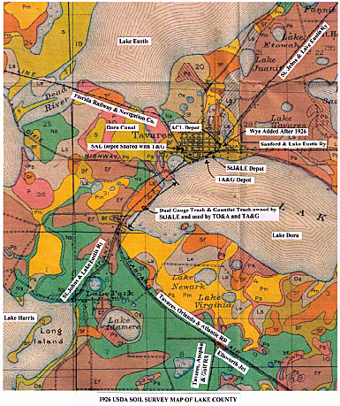
SLIDE COLLECTION FOR SALE
For Sale: Railroad slide collection. Over 1200 slides of motive power, rolling stock and depots from the 1950’s to present. Mostly originals including short lines and industrials. Asking $1000 or best offer. Mainly slides cataloged and will include my collection of locomotive rosters. For information write to “Slides”, P.O. Box 813, Inverness Fl, 34451, or phone 352 726-6237.
.

CHAPTER OFFICIERS

FLORIDA EAST COAST CHAPTER, NRHS

President Walter Smith (321) 757-3349
Vice-President Hal Greenlee (321) 636-3393
Treasurer Bob Selle (321) 632-0944
Recording Secretary Harlan Hannah (321) 636-7986
Historian Jerry Sheehan (321) 452-8649
Newsletter Editor (Interim) Harlan Hannah (321) 636 7986
National Director Tom Hammond (321) 267-8339

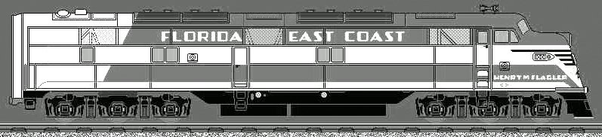

From http://www.getcruising.com/rails/_fec.html

Florida East Coast Chapter, NRHS
P.O. Box 238393
Cocoa, Fl 32923
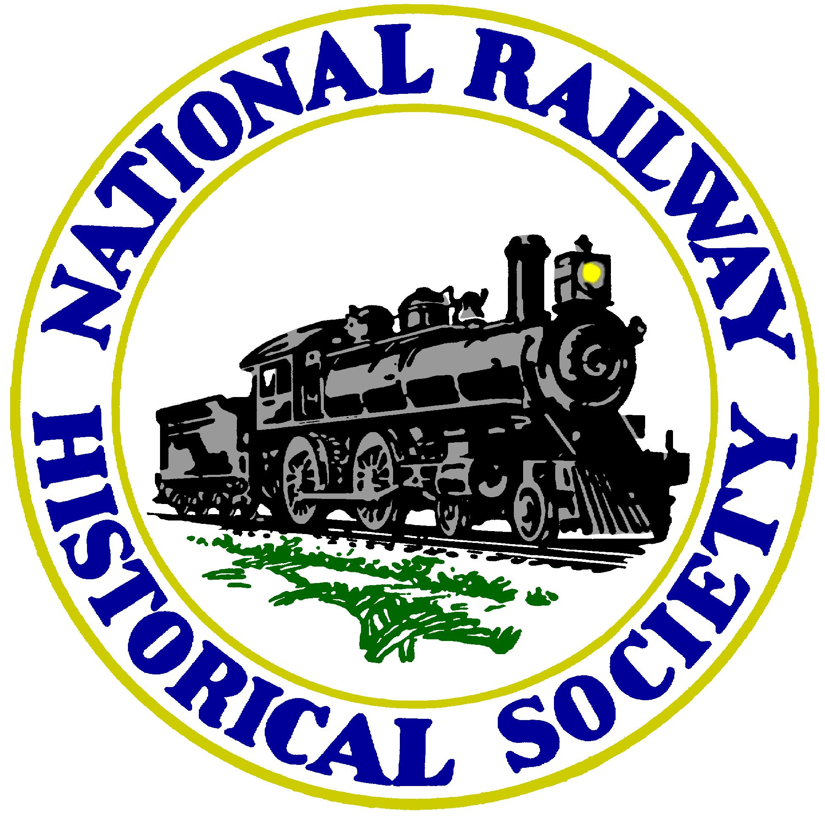

Next Meeting: Monday July 9, 7:00 PM
Central Brevard Library & Reference Center
308 Forrest Avenue, Cocoa, Fl 321 633-1792
Program: TBD

