The EAST COAST CHAMPION
January 2007

De 2006

2007 DUES
Bob Selle would like all chapter members to know that he has received the 2007 dues statements from our national headquarters. National dues remain at $22 as do our chapter dues of $13 for a total of $35. Bob would appreciate all those chapter members regularly attending meetings bring their check for their dues to their next meeting. The check should be made out to Florida East Coast Chapter NRHS. This will save the expense of mailing for both the member and the chapter.

MINUTES OF THE DECEMBER 2006 MEETING

Chapter President Walter Smith called the meeting to order at 7:15 PM on December 11, 2006. No guests were present. 15 chapter members were in attendance.

Raffle – Another mounted ALCO builder’s photo donated by Dick Alkus was raffled off. The raffle winner was Bob McMillion. In addition Stanley Bell donated five gifts to be raffled off. The Bob Robinson, John Caselli and the Secretary were winners of three of the items, but the remaining winners were not recorded due to the ongoing “mayhem”. The Secretary would like to thank Mr. Alkus and Mr. Bell on behalf of the chapter.

Treasurer’s Report –Bob Selle gave the treasurers report. There was no change from last month. Rich Nordstrom moved to approve with a second by Jim Carter. The motion passed.

Approval of Minutes –The President called for additions, corrections or comments to the August and September minutes as published in the “Champion”. None were offered. No minutes were recorded for October due to the cancellation of that meeting. As customary no minutes were recorded at the November Dinner meeting. John Caselli moved to approve the minutes. Stan Bell seconded the motion. The motion passed.

Old Business:
John Caselli reported on his efforts to obtain materials for a school program. John found that our National Headquarters has no educational program. John also contacted the American Association of Railroads who proved very helpful. John passed the sample materials supplied by the AAR to our chapter President Walt Smith. Walt intends to start by contacting the history department at Eau Gallie high school.

John asked for comments on our web site and commented that he had emailed the FEC’s vice president for marketing inviting him to speak to us. He received no response to his email.

New Business:
Bob Selle announced that the membership renewals will be due in January. Dues remain 35 dollars total for national and chapter dues.

The Secretary asked for program volunteers. Bob Selle agreed to present his program on FEC rolling stock in January. Hal Greenlee offered to present a program on his trip to the East Broad Top in February.

The Secretary passed out brochures for the Flagler Museum. The chapter has talked in the past about a field trip. The writer suggested that we consider a trip to the Flagler Museum and possibly meeting with some of the people from the West Palm Beach Chapter.

The chapter received a review copy of Seth Bramson’s new Arcadia Press book Florida East Coast Railway which he circulated for the meeting attendees to peruse. The Secretary asked for a volunteer to review the book for the newsletter. President Smith volunteered. The Chapter thanks Arcadia Press for the review copy.

Reports & Announcements:
Hal Greenlee announced that the Protorails convention will start on Friday, January 5,2007 and run through Jan 7, 9 AM until midnight at the Cocoa Beach Hilton, with layout visits on that day. All of the chapter’s regulars have heard Hal’s and the writer’s comments on this convention. Even if you are not a model railroader, this is an event worth attending. Hal also reported that according to FEC History and Technical Society web site the rumored colors for the new SD70s will be blue and yellow. And finally that a couple teenagers were arrested for throwing rocks at passing trains.

Program:

Walt Smith narrated a slide presentation of photos of the Erie Lackawanna from his personal collection.

Florida East Coast Book Review

Arcadia Publications has just released a book on the F.E.C. railroad by Seth Bramson. I was asked to review it and it has been a pleasure for the most part. This little soft cover book is LOADED with rare photos and information which will be new to most of us as well as to the dyed-in-the-wool FEC fans. At $19.99, it's a little pricey but if you're interested in the FEC, I'd say it's worth it. I don't know if this book is available from Barnes & Noble or other local retailers so for the convenience of those who might wish to buy it, Arcadia has a toll-free number.....1-888-313-2665.

Regards to all,

Walter E. Smith

ARCADIA PUBLISHING PRESS RELEASE

All Aboard for the History of the FEC
Railway enthusiast offers a historic ride on Florida East Coast Railway

Author Seth H. Bramson said, “Names and memories will come flooding back when readers pore over the great images and text that represent each chapter in this book.”

Highlights of Florida East Coast Railway:
- This is the first ever complete photographic history of the Florida East Coast Railway!
- More than 90% of the photographs in this book have never before been published.
- Loaded with extremely rare photographs, all from private collections, this book will be both a revelation and a delight to anybody interested in the history of America’s most exciting railroad.
- The book includes numerous photographs of items and FEC scenes that have never before been published or seen outside their owner’s collections.
- The final picture in the book features the FEC steam locomotive that was rescued fromcertain scrapping in Texarkana, Texas and brought back to Florida for restoration and eventual operation.
The book is dedicated to the employees and management of the FEC and features photographs of managers, supervisors and the people who actually make the FEC the best run, best managed, most profitable for its size, most exciting railroad in America

Available at area bookstores, independent retailers, and on-line retailers, or through Arcadia Publishing at (888)-313-2665 or www.arcadiapublishing.com.

Arcadia Publishing is the leading publisher of local and regional history in the United States. Our mission is to make history accessible and meaningful through the publication of books on the heritage of America’s people and places. Have we done a book on your town? Visit www.arcadiapublishing.com.

An Interview with the Author of Florida East Coast Railway

What was your inspiration for writing the book?
As one of the editors of American Heritage wrote to me, there can NEVER be too much written about the Florida East Coast Railway, America’s most exciting and best run railroad! This book was the opportunity for me to present both new photos and new information on this great railroad. AND, most important, more than 90% of the photographs in the new book have never before been published!

How did you research the information for the book?
As the Company Historian, with the largest collection of FEC Railway memorabilia in the world in OUR collection, it (the research) was done here, in the house. (“The Company’s Archives are in Miami Shores” --John W. McPherson, President, FEC Railway.)

What will readers find interesting about the book?
The new information presented in the introduction as well as the chapter prefaces PLUS the fact that of the 192 photos, more than 90% have never before been published. Only four or five of them appear in Speedway to Sunshine, the official history of the Railway.

What writing advice would you give to aspiring authors and historians?
Think carefully about your topic; write with passion and feeling for the subject and don’t write about something out of your geographic area UNLESS it is of major interest and you have researched it thoroughly. Above all, THINK about not only what you want to write about but whether or not—and this requires introspection—whether or not there is a legitimate market for that topic.

What lasting impact do you hope your book will leave?
It will, like Speedway to Sunshine, be an important historical reference for this incredible railroad, and a great source of historical facts for those seeking information on the FEC in the future.

STACK TALK

Neil Moran, January 2007

Hope you all had a wonderful Christmas and green lights ahead of you for 2007.
CHINA
Our first steam news of the New Year comes from China at He Gang station and yards. There a couple of SY class 2-8-2s powering freight trains in the area, but at He Gang itself there are several Mikados working the yards. However, back in the sheds quite a few of these engines are on storage tracks cold. Nevertheless these engines could be fired up at short notice. Crews are friendly here.
At the Mudanjiang Coal and Coke plant, two QJs with high steam deflectors have been spotted hauling freight trains between Mudanjiang and Jiamusi. This particular class of 2-10-2s with high deflectors was built back in 1972 and has outlived all the other QJs built in the l980s.
Over at Chengzihe exists another coal plant that has fifteen SY class Mikados under steam. The plant personnel are very friendly as several groups had a field day taking pictures the entire day. Especially when you give them 10 yuan. One particular photographer had three SY class engines coming toward him on three different tracks pulling coal trains. He said he couldn’t believe his eyes. An average of twelve to fifteen coal trains move between Jixi, Donggang and Chengzihe. A very busy place!
Moving to Didao, a Chinese National Railway (CNR) interchange, Mikados come in from Donggang Coke plant. Generally about three trains a day are on this line. Still in service at Didao is a steam engine washing facility, almost extinct in China. You can photograph many engines here as they come for servicing and a wash. As one photographer said “Here they come to you, and you don’t have to chase them.”
Over at Pingdinshan the steam shed is still very active servicing several SY class engines. They have freights between Pingdinshan and Shenyang. Photos are easily obtained for 5 yuan which is payable to the head of the facility. For another three or four yuan he will serve you lunch! Presently they are repairing a famous Chinese SY class #1216 that has much lettering on it.
Our final stop is at Yi Jing where several Mikes run passenger service between Yi Jing and Heishanton also a CNR interchange. Here again if you grease the palm of the engineer you can get a cab ride on this commuter line. The operation is quite beautiful especially in the winter with lots of snow on the ground and in the mountains areas. It also crosses a half-mile bridge over the Heishanton River, which is quite spectacular. Since some of the engines run tender first, the crew will allow you to climb on top of the tender to get head on photos, an extraordinary shot! Service with a smile while dropping a few coins in the hand.

INDIA
A broad gauge (5’6”) Beyer Garratt was recently restored to full operation a few months ago. This engine alone could pull the weight of 1,000 elephants. She is India’s biggest and powerful locomotive. The Garratt was restored by the Southeastern Railway, and had its inaugural run on November 11, 2006 between Shalimar and Mecheda on the Kharagpur division of the railway line. Sources said that N-class Garratt is the largest locomotive of its kind to run anywhere in the world. She also has the largest water capacity of any Garratt ever built, about 10,000 gallons. This engine was imported from Beyer, Peacock & Co. builders based in East Manchester UK in 1929. It originally ran on the Bengal Nagpur Railway and remained in service on that railway until 1969. The restoration took one year and the entire project included research and finding the right personnel, which took over two years. More than fifty people were involved in the restoration. This massive engine was also used on coal traffic between Chakradharpur and Jharsuguda, and also to Asanol. The engine was last used in regular service in 1970-71 hauling 2400 tons of iron ore from Daltirajha to Bhilai. Once the line was electrified this Garratt was sent to Kharagpur for storage.

SOUTH AFRICA
Moving to this country the steam news is diversified. Last month I reported that the World Soccer Cup Tournament, equivalent to our Super Bowl, was going to take place in this country in 2010. Presently, I have not heard from my contact, John Batwell, who is the assistant editor of South African Rail Publication.
What we do have to report is this. At the South African National Railway Museum (SANRASM) in 2006 this group had problems getting ready for their opening day activities. Its 14R class 4-8-2 #1909 was being overhauled due to a steam leak. This engine was originally built as a class 14A ninety years ago. The leak developed in the superheater vicinity. The smoke box was removed to repair the leak. This was a major undertaking. The work was completed after many days. The mountain class is back in operation once again. On occasion #1909 pulls excursion trains on the Doornkop branch line. Meanwhile the Museum’s other
Engine, a 6th class 4-6-0 #454, also had boiler problems but diligent repairs were done on her and the ten-wheeler recently passed its boiler inspection and is now in regular excursion service on the Harmony Gold Mine operation.
Up at Pretoria, the Friends of the Rail Society ran excursions on its Cullinan line using a 19D class 4-8-2 #2650, and a 24 class 2-8-4 #3664. This double-header was a smashing success. Almost at the same time Reef Steamers ran a trip on the same day to Cullinan with a 1SF class 4-8-2 #3016. In essence we had two excursions running on the same line but from different societies. Amazing!!! The Reef Steamers is actively engaged in getting a new home at Hercules not far from its present location at Capital Park. The Friends are also interested in possible excursions on the Volksrust-Bethal line which seems to be good condition.
Unfortunately we end our steam news from South Africa with some disturbing news. The famous George-Knysner operation that runs partially along the Indian Ocean coastline maybe be in serious jeopardy. Recent heavy rainstorms hit the area causing severe damage to the track and roadbed. Several washouts were reported and it is not known at this writing whether they will be able to repair the damage. If this is the case the demise of the George-Knysner RR could cause serious concerns to the area.

THE CZECH REPUBLIC
Sad news to report here. Steam excursions will be at an end quite soon; perhaps even by the time you read this. Secondary lines and depots are being closed, and locomotives still in operation will not be getting overhauls anymore. I believe the last tour with steam and authentic livery was run with 2-8-2T #433 002 and 464 202 out of Olomouc. Simply put, the Republic does not want to be bothered repairing these locomotives anymore and feel they are not making enough money from their excursions.

CANADA
Here are a couple of stories from our neighbors to the north. In North Vancouver C.N. yards formerly B.C. Railways Royal Hudson #2860 did a little moving around in the yards during the last weekend in November. The Friends of the #2860 had recently worked on its cylinders and wanted to see if everything was in proper order. So they ran her at several speeds within the yard limits with no problems. This engine sports a new paint job and looks as if she just came out of the back shops of the Montreal Locomotive works where she a was built back in 1940. So far there are no plans as to where she will operate in 2007. Rumors have it she may go up to Squamish B.C., her old route before heavy repairs.
Switching to the eastern part of Canada, the South Simcoe Railway had recently erected a large plastic tent that will house both former C.P. #136 a 4-4-0 that was built in 1883, along with former C.P. #1057 a ten wheeler built in 1912. Up until last year both locomotives had to be stored outside with just a tarpaulin over them. Now with this new facility, the workers can at least get out of the cold and into a heated area when repairing both engines.

UNITED STATES
Normally speaking during the winter months there is not much steam news to report but not so this month. On November 10, 2006, Soo Line #1003 ran an early Santa Train. She left the Wisconsin Automotive Museum (the home base of the Mikado) in Hartford with just a caboose. She then traveled seventeen miles to Horicon over the Wisconsin & Southern RR. There the 2003 picked up several passengers cars to use on the Santa Train. Early on Saturday Nov. 11 the train backed five miles from Horicon to Burnett, WI where she took on coal and water. She then moved to the station around 9 AM to be viewed by the onlookers and passengers. It left Burnett at 11:30 AM and ran back towards Horicon then on to Iron Ridge, Woodland, and Rubicon before arriving in Hartford at 1 PM. The steam train stayed there until 3 PM with people being allowed to visit up in the cab. Then it returned to Burnett later that afternoon.
At the Fort Wayne Railroad Historical Society their Nickel Plate Berkshire a 2-8-4 #765 was under steam for special sessions of “Throttle Time” which took place on Dec. 2. This operation was held in conjunction with the Society’s annual Santa Train and the release of Christmas cards featuring the #765. “Throttle Time” sessions were open to the public who could operate the locomotive under careful scrutiny for a certain time. The cost was $75 per person. Several times a day the locomotive stretched her legs by moving around the yards, blowing its whistle to the delight of the people who came. Everyone seemed to have a great time, and a 2007 schedule should be in the works fairly soon.
We have news of another Berkshire #1225 that resides in Owasso, Michigan. The train is under the auspices of the Steam Railroading Institute. This engine powered several North Pole Express excursions during the months of November and December. She departed the Steam Railroading Institute depot in Owasso and headed to the North Pole at the Saginaw County Fair Grounds which was a 24 mile round trip. Trips began at 4 PM on Nov. 24 and continued every Sat. and Sun. at 10 AM and 4 PM through Dec. 17. An array of children’s activities was scheduled including games, rides, and interactive shows. Upon detraining at Saginaw Santa was there to meet and greet the incoming train. All trips were sold out. The #1225 pulled four coaches and two cabooses with about 300 people on each trip.
Now let’s move to Portland, Oregon where the ex-SP #4449 hauled several holiday express trains that were sponsored by the Oregon Rail Heritage Foundation. Trains departed from Oak Park in southeast Portland for a forty-minute trip over the Oregon Pacific RR. They traveled through the Oak Bottom Wildlife refuge along the Willamette River. The locomotive along with the entire holiday train were decorated with thousands of lights, much to the chagrin of the purists! Three departures were scheduled for Friday Dec. 8, then on Dec. 9, nine departures were listed, followed by nine more on the 10th. The same weekend scheduled was repeated on Dec. 15-17. It was not known at this writing whether the SP&S #700 was involved with this occasion. Right now these engines are stored in the Brooklyn roundhouse in Portland along with Oregon RR and Navigation (ex UP 4-6-2 #197). Time is running out at this location and all proceeds of these trips went to the ORHF, whose mission is to build a permanent home for these locomotives.
There are two railfan events coming up this month that you should not miss, especially for steam fans on the east coast. This will be a joint effort with two railroads involved. On Saturday Jan. 27 at the New Hope & Ivy’s engine #40, a 2-8-0 Consol, will depart at 8 AM from the station hauling a number of vintage freight cars along with a coach and dining car. During the day there will be many photo runbys, some with the passenger cars off and some with passenger cars on. The train returns to New Hope at 5 PM. Later that evening Steve Barry will conduct a night photo session. The following day, Sun. the 28th, you head down to the Wilmington &Western RR for a day’s activity. This time you ride on a steam passenger train pulled by #98 a 4-4-0 built at the Schenectady Works in 1909. The consist will include a combine car and three coaches. Departure is at 9:30 PM and returns at 3:20 PM. Again many photo runbys are planned and there will be special photo opportunities at both railroads to get both engines at different settings.
The place you want to be next month is out at the Nevada Northern Railway on February 2, 3 & 4. Here the snow should be as high as an elephant’s eye. This year there will be two locomotives under steam, #40 a 1910 Baldwin ten-wheeler, and #93 a 1909 ALCO Consol. These engines will power freight and mixed trains along thirty miles of track including a tunnel, cuts, and alongside mountains. Included with this is a magnificent railroad station dating back to the turn of the twentieth century. You can also visit the shops where the restoration and upkeep of the locomotives and rolling stock are stored.
Between Feb 4 and 6 you can leisurely drive to the Heber Valley RR and take in the second part of this seven-day adventure. The Heber Valley offers spectacular winter settings deep in the Watasch Mountains. Magnificent views are seen when the train enters the deep canyons along the Provo River. Once again many photo runbys will be held during this three-day snow special. The engine you will be viewing here is an ex UP Consol #618. The train will vary from a solid freight train to a mixed consist throughout the day. Be sure to bring tons of film, as the scenery at both railroads is awesome. Don’t forget the long johns!
Now I want to thank the following for the news you just read. John Biehn (Dayton RR Society), John Batwell (SAR Publication), Ed Emery (Toronto, Canada), Bruce Russell (NRHS-NY), Richard Taylor (NRHS-NJ), and from your most humble servant in steam.

UNTIL OUR TRACKS CROSS AGAIN

TRAIN STORIES AND NEWS
Proposed Miami Streetcar System Swells, But Schedule Slips

Miami: The Miami Streetcar project, brimming with potential, is nowhere closer to completion as its size and costs continue to swell and its anticipated start date slips further into the future, according to a story in the Miami Herald. The original $132 million plans called for cars to run on 6.75 miles of track that would be laid on some of the very same city streets where trolleys rambled 80 years ago between downtown and the Design District.
But last year, city planners quietly added an east-west loop that would run from Wynwood, along the NW 20th Street corridor, to the hospitals, medical research centers, courthouse, and law offices at the Civic Center complex. The estimated price tag has swelled to approximately $200 million.
“We felt like it was important to serve one of the city’s biggest employment centers as part of this same project,” said assistant city transportation planner Lilia Medina.
The east-west spur dovetails with the Miami Partnership and the University of Miami’s plans to expand and improve the hospital district. A rubber-tired bus, designed to look like a trolley, was being considered as a circulator in the area.
The Civic Center spur would guarantee the streetcar serves some hardscrabble neighborhoods, Lindsey Hopkins Technical College and a popular row of mom-and-pop retail shops that are patronized by lower-income residents and recently arrived immigrants.
How the city pays for the project is very much up in the air, said city transportation planner Mary Conway.
Miami officials originally hoped to issue bonds to leverage the city’s cut of the half-cent sales tax - currently $10 million a year - to underwrite a large chunk of the system. Now they are looking at a wider array of public and private options, including an independent authority, a joint-operating agreement with Miami-Dade Transit or even hiring a private firm that would design, build, operate and maintain the system for a fee.
Conway acknowledges that the originally optimistic start date of 2008 has already slipped to a “best-case scenario” of 2010.

CHAPTER OFFICIERS

FLORIDA EAST COAST CHAPTER, NRHS

President Walter Smith (321) 757-3349
Vice-President Hal Greenlee (321) 636-3393
Treasurer Bob Selle (321) 632-0944
Recording Secretary Harlan Hannah (321) 636-7986
Historian Jerry Sheehan (321) 452-8649
Newsletter Editor (Interim) Harlan Hannah (321) 636 7986
National Director Tom Hammond (321) 267-8339

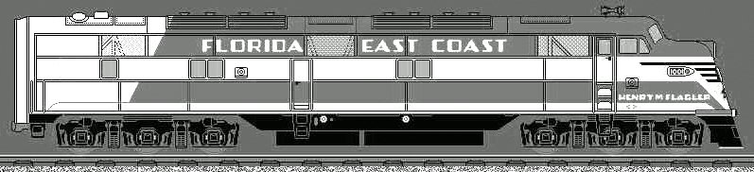

From http://www.getcruising.com/rails/_fec.html

Florida East Coast Chapter, NRHS
P.O. Box 2034
Cocoa, Fl 32923
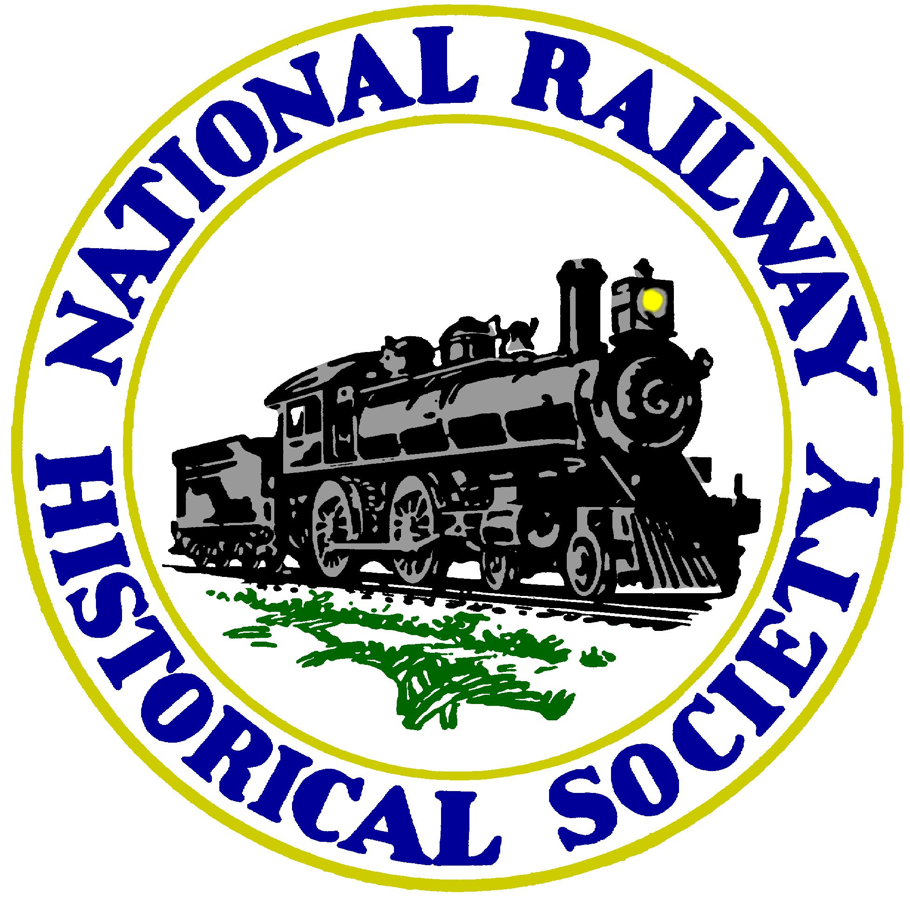

Next Meeting: Monday January 8, 7:00 PM
Central Brevard Library & Reference Center
308 Forrest Avenue, Cocoa, Fl 321 633-1792
Program: Bob Selle, FEC Rolling Stock

