The EAST COAST CHAMPION
_____________________________________________________________________April 2005
APRIL MEETING LOCATION

800 PALMETTO AVE, MELBOURE FL
This location is for the April Meeting only.
Contact Stan Bell at 321-952-5221 or 321-779-3392

PRESIDENT’S MEMO TO STOCKHOLDERS

The April meeting will be at Mr. Stanley Bell's house in Melbourne where he has a large layout & room enough for all of us to enjoy it. I want to include instructions to this house.
Coming South on US 1, you should make a right turn just one block prior to US192 in downtown Melbourne. This will be Palmetto St. cross the FEC tracks and the first intersection will be Waverly Street. There is a small gray house on the corner (800 Palmetto. It has a huge RR Crossing sign on the front of the house - this is the place. Make a right turn onto Waverly &
there will be a small parking lot. Park there & enter the garage at the rear of the house. Any questions feel free to call 952-5221.
I will try to be there, but may have to go North on business (& miss all the fun).
Regards to all,
Walter E. Smith

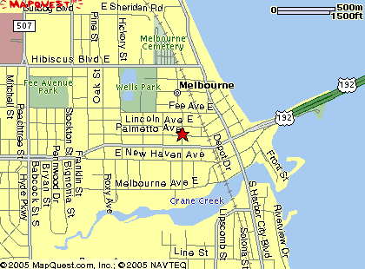
MINUTES FROM THE MARCH MEETING

Chapter President Walt Smith called the meeting to order at 7:05 PM on March 14, 2005. There were no guest or visitors in attendance.

President Smith raffled off a Lionel wall clock that Bob Sowden had generously donated. Stanley Bell won the clock. Stan indicated that it would be proudly displayed in his train room.

Treasurer’s Report
– Bob Selle gave the treasurer’s report. Bob reported that all but 3 past members had renewed. Jim Heidel and Bob McMillion were mentioned as exceptions. Bob Selle expressed confidence that Bob McMillion would be renewing. Dick Alkus made a motion to accept the Treasurer’s Report. Stan Bell seconded the motion that passed by show of hands.

Approval of Minutes
- The Secretary called for additions or corrections to the January meeting minutes as published in the newsletter. None were offered. Dick Alkus again made a motion to accept the minutes. Stan Bell also seconded the motion that passed by show of hands. In the absence of both the chapter’s president and secretary in February no business meeting was conducted or minutes recorded.

Old Business
- None.

New Business
- Stan Bell extended an invitation to visit his high rail model railroad. Stan’s “train house is located adjacent to the BellSouth tower in Melbourne near US1 and 192. Following open discussion regarding when to schedule the visit Stan mentioned that the Sebastion Model Railroad Club meets at his location. A suggestion was made that we dispense with usual business meeting and program and hold the next chapter meeting at Stan’s layout. Walt Smith offered a motion that the next meeting be held at Stan’s train house which passed by show of hands.

Reports & Announcements:
- The writer reported upon his visit to the Tazewell County Historical Society in Pekin Illinois. The historical society acquired, last fall, the archives of the Pekin & Peoria Union Railroad after the railroad was acquired by the Genesse & Wyoming. In addition to that they have an estimated 150 file drawers of Illinois Terminal Railroad Archives. They are trying to catalog this material and are looking for support to catalog this material. I started looking at random in file folders and found material ranging from ICC meeting minutes to a 1909 map of tracks and facilities in Pekin Ill,
- John Prestopino announced that he was returning to New York State for the summer. He will be volunteering again on the Catskill Mountain railroad.

Program: Hal Greenlee: Tracks ahead in HDTV.

RAILS ON THE WEB

For this month try the Library of Congress’s Collection of railroad maps: http://memory.loc.gov/ammem/gmdhtml/rrhtml/rrhome.html.

Upcoming Events
Electric Railway Club of Florida, 20th Annual Meet, April 8-10, John Knox Village South of Deland;
4/8-12am to 11pm, 4/9-9am to 11pm, 4/10-9am to 12pm; Contact Janet/Jim Richards 386-775-4777,
4 Ivy Ct. Orange City Fl, 32763, JanetGRR@695online.com

PBS Television Programs:
Thursday April 14, 9pm: “Super Chief; Speed, Style, Service”
Thursday April 21, 9pm: “Trains of the West”
Thursday April 28, 9pm: “Rockies by Rail”
NEWS AND INFO FROM CHAPTER NEWSLETTERS
From the Tampa Bay Chapter “The Orderboard” (and The NRHS web site)

The Fireless Locomotive
By Hank Nioms
The fireless locomotive is one of the most remarkable and foolproof locomotive designs devised. A locomotive equipped with a large tank or reservoir instead of a boiler and firebox, it carries no fire. This engine was essentially a giant thermos bottle lying on its side with wheels.
This type of locomotive was very desirable for service in plants where cleanliness and the elimination of lire hazards and noise were important. They were quite popular in applications where smoke and cinders could ruin the product, as in textile mills or agricultural processing plants. In those applications where this type of locomotive fits, it was a reliable and economical unit of motive power. Fireless locomotives could be found working in chemical industries, powder plants, paper mills, food plants and electric power plants wherever a reliable source of steam or compressed air was readily available.
Before the perfection of electric street traction in the 1880s, American city railways tried many exotic forms of power in an effort to displace horse-propelled cars. In the l870s the Crescent City Railway of New Orleans tried some steam storage motors built in Paterson, NJ, by Theodore Scheffier in 1876. These locomotives were fireless and obtained a “charge” of steam from a stationary boiler house. Fireless locomotives were extensively used In Europe long before their introduction in this country. The first European-built fireless was brought to the U.S. in 1913.

Types Of Fireless Locomotives
There were two types of fireless locomotives: one used steam, the other compressed air.
In a fireless steam locomotive, in place of a boiler, the locomotive is fitted with a cylindrical tank that is charged with steam and hot water from a stationary plant. The storage pressure usually approximates the working pressure of a locomotive boiler; but the pressure of the steam is considerably reduced before it enters the cylinders. These locomotives are simple in construction and, as they cannot explode, they are exceedingly safe to handle. As a rule, but little equipment must be installed for their operation, as the majority of industrial plants are supplied with the boiler capacity necessary for charging the locomotives.
The reservoir/tank stores heat in the form of hot water and steam. Steam is charged into reservoir at valve marked “Charging Connection”. The steam is admitted at bottom through a perforated pipe so that temperature of the entire body gradually raised.
The time required to take on a full charge can vary from 10 to 30 minutes, depending on the charging pressure, the size of the reservoir, and how low the charge was before being refilled.
When the reservoir is fully charged, 85 percent or more of its volume is filled with hot water and the remainder with steam. As steam is drawn off and used in the cylinders, pressure in the reservoir drops and some of the hot water flashes into steam. This newly created steam draws its heat of vaporization from the hot water which remains in the liquid state and, as a result of the vaporization, the temperature of that water is reduced. This continues until the temperature of the water drops to the point below which it will no longer vaporize into steam at sufficient pressure to be used in the cylinders. The cylinder proportions are such, however, that the locomotive can move itself on very much less than the normal working pressure.
Normally, one charging, or one full plus several partial chargings, will keep a fireless locomotive at work for a full day. Steam for charging may be obtained from any available source, such as the plant’s steam supply, and is delivered to the locomotive reservoir through a flexible charging connection. One centrally located charging connection is usually sufficient, but where the locomotive operates over a large area more than one charging station may be desirable from the standpoint of convenience and economy.
The reservoir contains only a few working parts: these include the charging pipe, check valve, throttle and throttle rod, and dry pipe.
Prior to recharge, the combination boiler water tank would be 80 percent filled with water. It would then be connected to an external steam line, which would heat the water in the tank to temperatures of 400 F.
With internal tank pressures rising up to 400-psi. The cylinders would operate at pressures of 150 psi. After a recharge, the steam heater line was disconnected and the driver would open the throttle, resulting in the sudden generation of “flash steam” inside the boiler/water tank, as a slight pressure drop occurred. Like its counterpart which carried an on-board firebox, the fireless too required the occasional reservoir washdown to remove scale. This could be minimized or eliminated with the use of distilled water. Another way this cost can be reduced and efficiency can be improved is by switching from an open system of’ exhausting waste steam and refilling the water storage tank, to a closed system which recycles the water.
A second category of fireless locomotive is the compressed air type. Basically, it’s a locomotive whose boiler has been replaced with one or more compressed air cylinders. The cylinder would store air compressed to 600 psi and through a step-down valve, the cylinders were driven with 150 psi. Except for the medium, a compressed air locomotive’s advantages were identical to those of a fireless steam locomotive.
Compressed air locomotives were frequently used in mines where the steam locomotives were much too dangerous to operate. Mines often had a problem with methane gas buildup; therefore, a spark from a steam engine could create an explosion. Also, there was a lack of storage space for fuel and the exhaust from a steam engine had nowhere to escape, posing a threat to the miners ability to breathe. To use electric trolley wires was a very dangerous solution. Wires caused sparks and men and animals- such as mules, which were frequently used around mines, were easily electrocuted by accidentally brushing against the open wires.
While Porter wasn’t the first company to produce compressed air locomotives, it was as the first company to make compressed air locomotives for industrial and mine applications.
Porter sold a compressed air locomotive to a mine in Vivian, WV in 1896 for use in a mine and two more to the New Orleans and Western Railroad for use in cotton sheds.
Also in 1896, Porter supplied ten compressed air motor cars for the Eckington System in Washington, D.C. The cars looked like normal cable cars and had the ability to have cars coupled to them. There was a tank on the front of the engine and it was recharged at the station. By Porter’s estimates, by 1901, the company had sold 90 percent of the compressed air locomotives in use in the U.S. These locomotives were also used in tunnels, especially those over 40,000-ft. in length where ventilation could be poor and gas buildup a hazard. In fact, the exhausted air actually improved ventilation in mines and tunnels.
In mines, the locomotives were filled with compressed air at a stationary compressor, or the air was pumped through a pipeline at different stations for the tank to be recharged. Flexible couplings were introduced so the locomotive would not have to be stopped in a precise position to be recharged.
In 1908, Porter began too build a two-stage compressed air locomotive with an interheater inside the tank to increase efficiency and decrease time spent recharging the tank. The compressed air locomotives were eventually replaced by battery and electric locomotives because they could haul more and required less charge time.

Makers of Fireless Locomotives
Baldwin made two types of fireless steam locomotives: Narrow Gauge Type 0-4-0, available in gauges from 2 feet 6 inches to 1 Meter, Class 4-C; and Standard Gauge Type 0-4-0, standard (4 ft. 8 1/2" in.) gauge, Class 4-C.
H.K. Porter Company built its first compressed air locomotive in 1891 or 1892, but didn’t build one well enough to meet its standards until 1895. Porter built its first fireless steamer in 1914. In total, Porter built more compressed air locomotives than fireless steam units.
Heisler Locomotive Works built (20) 0-4-0, (7) 0-6-0, (1) 0-8-0 and one geared fireless steam locomotives (shop numbers 33 to 61). While Heisler began building fireless locomotives in 1933, but the first one of known record was outshopped in 1934. They were built in weights from 30-to 95-tons. From 1934 until the plant closed in 1941, Heisler built at least 29 fireless locomotives.
The largest was a 0-8-0 built for the Hammermill Paper Company. It came with 48-in, drive wheels and 30-in. x 28-in. cylinders and weighed 95 tons. It had a rigid wheelbase of 14 ft. The storage vessel was 84-in, diameter x 29-ft. 5-in. This gave it a capacity of 1,080 cubic ft. It was a failure. It was too heavy for Hammermill's track and the wheelbase couldn’t negotiate the switch leads and ended up spreading the rail. Originally painted blue, it was nicknamed Blue Bird. After its rejection, it was renamed White Elephant. A year later, it was purchased by Pennsylvania Power and Light Company at Hauto Pa. It’s now on display at the Railroad Museum of Pennsylvania in Strasburg.
The most unusual fireless steam locomotive was a gear driven model from Heisler. Instead of the direct connected rod type wheel arrangement, it had the same trucks as used on the Heisler geared locomotives, but had two horizontal cylinders, located one on each side. The engine and cylinders are enclosed but it had piston valve cylinders and Walschaert Valve Gear. It had a very long steam storage vessel and it more nearly resembled a tank car than a locomotive. It was built for the Allan Wood Steel Company in Conshokocken, Pa.
Vulcan built compressed air locomotives in standard or narrow gauge configurations. It offered 0-4-0 and 0-6-0 versions. A customer could order either single or dual tank designs. The single-tank, four-driver version came in four versions with tractive efforts from 1,860 to 4,IOO lb. The double-tank, four-driver version came in seven versions with tractive efforts from 1,862 to 8,815 lbs. The double-tank, six-driver version came in seven versions with tractive efforts from 3,180 to 11,492 lbs.

Features of Fireless Locomotives in General:
Easy to Operate—There were no complex controls or boiler to lire on a fireless. There is nothing to do but pull the throttle to start and apply the brake to stop. New, unskilled labor can learn to operate it after a few brief instructions. Fireless locomotives were rugged and can’t be damaged by inexperienced operators. Only one person is needed to operate the locomotive. When the engine is idle this person can be at work elsewhere, as there is no fire to keep tip or water level to watch.
Easy to Maintain —Due to the absence of the firebox and smokebox, two of the high maintenance items on a traditional steamer boiler were eliminated. There were no flues, staybolts, grates, air compressor, electric motor, generator, or internal combustion engine on a fireless. In fact, there were very few working parts. The reservoir never needs replacement. Repairs were few and far between. Thus the cost of maintenance is amazingly low.
Costs No More—A fireless costs no more than any other type of locomotive of equivalent power. There’s no investment or provision necessary for storing and handling fuel and water, or removal of ashes. The savings in operation and maintenance costs make it a very economical locomotive to own.
Cleanliness —There were no fumes or dirt from a fireless, an important advantage when operating inside a building or wherever smoke and cinders would be a disadvantage.
Long Life—The first fireless was placed in service in 1914 and was still working several decades later.
High Availability—Since the fireless runs on readily available steam or compressed air from the plant, it requires no firing-up period. It’s available for use as soon as charged, and, since the charging can be done during idle time, the fireless is available for use during practically any and or all working hours.
Costs Less to Operate—A fireless carries no fuel. It uses low-cost steam produced in the plant’s stationary boilers or compressed air from the plant’s system. Charging can be done during idle periods. No night or weekend attention is needed. As there’s no handling of fuel or firing, the operator can devote all of his/her time to the actual job of switching. No waste of steam through pop valves or operation of injector.
Safety—No danger of operator being burned or scalded. There is no lire hazard with a fireless. Since excessive pressures were impossible, there is no danger of an explosion. Explosions with this type of locomotive were unknown, because there is no crown sheet to burn on account of low water, no staybolts to break or flues to fail and weaken the boiler.
Quiet Operation—A soft exhaust hiss is the only sound heard from a fireless locomotive

Features Of A Fireless Locomotive Compared to an Internal-Combustion-Powered Locomotive:
Low Initial Cost—Steam/compressed air for the fireless is usually about one-half the cost of the fuel for a gasoline unit. No investment or provision necessary for storing and handling fuel.
More reliable—Its successful operation does not involve the proper functioning of a clutch, ignition system, fuel system, transmission, timing gears, radiator, fan and water circulating system. A fault with any one of which may temporarily put the locomotive omit of commission.
Easier to operate—No engine to start, clutch to disengage, or gears to shift.
Safety —No inflammable fuel to handle or electric sparks to ignite gases in refineries or other hazardous places.
Noise — Significantly quieter in operation.
Environment — No dangerous carbon monoxide or other obnoxious products of combustion.
Fireless locomotives were built for tank pressures from 85 psi up to 450 psi, according to available steam/compressed air pressure. Higher steam/compressed air pressures require heavier tank plates, thereby increasing the weight of the locomotive correspondingly.
While the fireless locomotive is the simplest of all haulage units, it involves problems in design as extensive as the variables of the steam tables which govern its operation. Although in appearance and general construction the fireless follows closely the conventional fired locomotive; there is hardly an essential detail of the latter which can be used for the fireless engine without vastly important alterations. For example, in designing pistons and rods, guides, crossheads, crank pins, side rods, etc. for a fired locomotive maximum stresses were definitely fixed by a practically uniform boiler pressure.
The fireless locomotive must not only he designed for maximum efficiency at low pressure including the important item of braking but rods, crank pins and other parts must be protected against contingent stresses which were possible up to the maximum pressure to which the tank can be charged. Auxiliary equipment such as brake cylinders, generator for headlights, lubricators, etc., must operate positively and with maximum efficiency with pressures varying over a range of 90 percent.

Fireless Steamer to Run Again
In order to concentrate its resources on the preservation of electric traction, the Connecticut Electric Railway Association Inc. (East Windsor, Conn.) has chosen to eliminate its collection of steam-powered locomotives. The Museum’s H.K. Porter 40-ton, 0-4-0 fireless steam engine No. 51 has been sold to RailStar Corporation of New ‘York. RailStar is planning to restore the Porter for eventual use in demonstration service. The locomotive was scheduled to be moved to its new home in the winter of 2001.
Built in 1934, the standard gauge fireless served The Stanley Works in New Britain, Comm. as a switching engine, moving cars in and out of the buildings and sidings. It relied upon Stanley’s stationary boilers to provide the high-pressure steam needed to till its large reservoir.
Stack Talk
Neil Moran

Spring is now upon us and every man’s fancy turns to steam activities or am I being a bit facetious?
China still holds the spotlight as far as foreign steam is concerned. The country is on its deathbed, as so little steam trains will be running as you read this. As of March 15th steam with freight and passenger service officially ceased running over Jing Peng Pass. Already gone are the coal railways at Zouxian, Tienchun, Huaibei, Yongcheng, Luohe and Fuyang. Both industrial railroads at Xuzhou and Shengjie are history as far as steam power is concerned. Further reports state that all passenger trains between Daban and Chabuga have now changed to diesel power, but there are some 2-10-2’s powering freight trains still running between these two cities, however, on an infrequent schedule. Recent reports state that steam will possibly last until the end of 2005.
As I write this the QJ’s 2-l0-2s are operating over Jing Peng Pass. It is now down to a trickle between Daban and Haoluku but mostly at night. The daytime saw only one train, and that was not operating on a daily basis. Strangely enough groups from various countries are still chartering between Haoluku and Daban. How long this will last is anyone’s guess and when these charters stop running so will the QJs 2-10-2’s. Good Night Sweet Prince!!
We next jump across the Pacific to Vancouver, BC The Provincial Government has recently given the C.P. Royal Hudson Group an additional $150,000 toward her restoration. The grant could not have come at a better time as work has begun to dissemble the 4-6-4 right down to her frame. The outside jacket has already been removed and work has begun on the steam chest. This project will take the remainder of the year and into next year. It is a major overhaul from top to bottom.
Up in Squamish another CPR locomotive is being restored. This is the #37 16 Consol that used to run on the former British Columbia Railway from North Vancouver to Squamish, when the Royal Hudson went in for repairs. It was to be tested in March and since this column was written in late February, the results of the test are not conclusive. She was built back in 1912 at the Montreal shops and worked on several divisions of the C.P. Railroad until her retirement in the 1950s. This locomotive has recently been completely overhauled by the shop in Squamish and may run on the Kettle Valley Railroad in western Canada.
Heading east our next stop is a Kamloops. Unfortunately, the news is not as good as the previous two stories. The repairing of the bridges, which were damaged by the forest fire that raged west of Kamloops more than a year ago, is still not completed. This year the #2 141 will make shorter trips out of Kamloops to an undisclosed location until the bridges are repaired. The locomotive has undergone some minor repairs over the winter and should be ready for service this spring.
Our next location is Calgary and good news awaits us here. The “Hudson” #28 16 has been thoroughly inspected and is facing a heavy schedule again. One of her big adventures is being operated by “West Coast Rail Tours” the westward trip departs Calgary to Vancouver and eastbound Vancouver to Calgary using a different route.
The westbound departure leaves the C.P. Pavilion in Calgary on June 29th with stops at Banff and Lake Louise where passengers will spend the night. June 30th it departs from Lake Louise and heads for the Continental Divide. At Kicking Horse Pass, it enters British Columbia and descends the grade through the majestic Spiral Tunnels into Field for a brief stop. After servicing, the train heads for Golden and up towards Rogers Pass, and eventually Revelstoke for the evening. On July 1st the “Hudson” continues west to Kamloops for an overnight stay. The following morning it departs from Kamloops, skirting the Kamloops Lake, enters the beautiful Thompson and Fraser River Canyons and ends its journey in downtown Vancouver at the Waterfront Station on the same day. Some time after her arrival it is expected that the “Hudson” may power a special excursion train down to the NRHS Convention in Portland, Oregon. However, details are still incomplete.
On July 13th the return trip to Calgary begins with a departure out of Vancouver towards the Fraser and Thompson River Canyons arriving in Kamloops that evening. On July 14th there may be a possible chance to see the “Spirit of Kamloops Heritage Train” headed by the Canadian Northern 2-8-0 #2141. Then it is off to Revelstoke and Golden. Now here is where the change of scenery takes place. Leaving Golden on July 15th, the train diverges from CPR and heads south over the former Kootenay Railway line to Fort Steele home of the mile circular double loop track surrounding the Fort Steele Heritage Park. At the park passengers can ride behind a 2-6-2 #1077 that was built in 1923 at the Montreal shops, or an 1895 Sharp & Stewart 0-4-4 T. This engine was built for the “Duke of Southerland” in Scotland in that year. Reboarding the train the following day on July 16th the special then travels through the spectacular Crows Nest Pass with an overnight stay at this location. Then on July 17th the final day, #28 16 heads for Lethbridge. Here the train will make two photo runbys over this famed one mile, 300 foot high trestle. Surely one of the highlights of this trip. The final stage of this adventure is from Lethbridge up to Calgary. By this time you will be totally exhausted but completely satisfied. To contact West Coast Rail Tours call 1-800-722-1233 or Tours@wcra.org.
Our last stop in Canada will take us to Stettler, Alberta home of Bullet Nose Betty. This former CN Mountain class 4-8-2 will make her first runs of the season over the Easter Day weekend with a round trip up to Big Valley. During this past winter she had minor repairs done to her and as now been classified ready to go by the crews in the shop. Rumors have circulated that it may do something with the #2816 Hudson, but when or where is still up in the air.
Back out West, but on our side of the border, the Timber Heritage AssociatIon of Humboldt County in northern California is currently raising funds to enable them to restore its newly acquired locomotive #37 a 2-8-2 tank engine, built by Alco in 1925. The Mikado worked in the Sierras hauling sugar pine before being sold to the Pacific Lumber Company in 1935. There it was used as a logging locomotive hauling redwood, usually in the Yager Creek area, until her retirement in 1956. Eventually the engine was purchased and relocated to Wilmington, Delaware where it began operating on the Wilmington &Western Railroad. The Timber Heritage Association’s vision is to run an excursion train around the Humboldt Bay area, and maybe elsewhere on the Northwestern Pacific Railroad to help improve the economy in that vicinity.
The upcoming convention in Portland Oregon is taking on a more positive appearance now. According to several sources former Southern Pacific #4449 and SP&S #700 will at least make a showing at the night photo session. The group is hard at work trying to arrange some excursions with either or both engines. At present there is a fifty-fifty chance that the Union Pacific #8444 will make a trip from Cheyenne Wyoming to the convention site. If this happens the 4-8-4 will possibly make a trip out of Portland along the southern shore of the Columbia River to an undisclosed location. However this is not written in stone. Other things may develop such as the C.P. Hudson #28 16 coming down from Vancouver BC with a special excursion. Though it is doubtful it will participate in any conventions activities. With so many details to be ironed out, such as sky high insurance rate, dates that steam excursions can operate on the main lines, availability of crews and locomotives, the NRHS Chapter has a hard task in front of them. Ten years ago local chapters did not have all these problems.
On May 21st and 22nd Lake Central Rail Tours in cooperation with the Steam Railroading Institute along with the Tuscola & Saginaw Bay Railway has announced the Pere Marquette Limited is ready to roll. This overnight steam excursion will run out of Owasso up to Cadillac, Michigan and return and will be powered by the Pere Marquette Limited 2-8-4 #1225. This locomotive became very famous in the recent production of the movie “The Polar Express” which starred Tom Hanks. Passengers will have the option of riding one way on a bus return, or riding both days on the train with an overnight stay in Cadillac. There is an additional option with a side trip on Sunday out of Cadillac to Yuma, Michigan. Scheduled departure from Owasso is 9 AM, with arrival at Cadillac around 3 PM. A round trip ticket including lodging is priced at $275 coach and First Class $395 including four meals. For further ticket information, contact LCRT at www.lakecentralrailtours.com
We have history in the making at our next stop. Ex Southern Pacific #768, the centerpiece of the Austin Steam Train Association of Austin Texas, is undergoing major repairs. On December 8th, the Fairmont Foundry of Hamburg Pa. successfully completed the first of two cylinder castings for this engine. Possibly the first time a new steam locomotive cylinder has been cast in the US in over fifty years. The second half was cast on Dec. 16th• Both castings will need to be machined before they can be installed in the frame of the #786. Work is well underway thanks to generous grants totaling $360,000 from the City of Austin, the City of Cedar Park and the Heritage Society of Austin. While every part of the #786 is being thoroughly rebuilt from top to bottom, the centerpiece of her overhaul is the replacement of her cylinder saddles. This is a massive ten-ton assembly that is literally the heart of this machine. Many question the return of the locomotive. With a complete refurbishing project still being worked on, the Society hopes to complete it sometime this year.
The news on the Western Maryland in Cumberland, Maryland is not a s good as the last story. The railroad has already ripped up the track from Woodcock Hollow Road up to Frostburg last year. This action was due to a new hiking trail that has partially been installed. This action destroyed the railroad’s ability to turn the locomotive on the turntable at Frostburg. Now they can only run up to Woodcock Hollow Road and use the siding in that area to run the engine around the train to proceed back to Cumberland. In recent news just received the State may reinvest millions of dollars to restore the torn up track. However, this is not certain. The really bad news is that the railroad will undoubtedly abandon the line after this year. A disaster in the making!! Questions arise what will happen to the #734 after this year and what will happen to the rolling stock and what will become of the prominent railroad station in Cumberland? Gone also will be the famous Helmstetters Curve and Brush Tunnel! Rumor has it that the operation may move to another part in Maryland. All because of a hiking trail! More railroad history bites the dust!
I’ll end on a better note. The Great Smokey Mountain Railroad in western North Carolina is receiving a 7.5 million dollars direct loan from the Federal Railroad Administration (FRA) to rehabilitate its infrastructure and maintain its economic importance to the region. This money will be used to refinance existing debts and upgrade four miles of track to heavier rail and replace over 38,000 railroad ties. The railroad will also purchase and install two turntables. By refinancing existing debts, the Great Smokey Mountain Railroad will have more cash available for maintenance and capital improvement expenditures. The GSMR operates primarily as a tourist line and carried over 167,000 passengers in 2004. It also handles freight shipments along their 53 miles of track. They employ about 46 full time people and nearly 140 seasonal workers. Most important the railroad provides an estimated 50 million in economic benefits to the region annually. The railroad uses a former US Army 2-8-0 Consol on its excursions. It follows along rivers, passes villages and valleys, and goes over trestles and through a tunnel. Truly a relaxing atmosphere.
Now it is time to thank the people who made this news available
John Biehn (Dayton Railroad Society), Steve Barry (Railfan and Railroad Magazine), Ed Emery (Toronto Canada), Jim Gregory (Piedmont Chapter NRHS), John Reilly (RRE New York), and your most humble servant in stream.

CHAPTER OFFICIERS

FLORIDA EAST COAST CHAPTER, NRHS

President Walter Smith (321) 757-3349
Vice-President Hal Greenlee (321) 636-3393
Treasurer Bob Selle (321) 632-0944
Recording Secretary Harlan Hannah (321) 636-7986
Historian Jerry Sheehan (321) 452-8649
Newsletter Editor (Interim) Harlan Hannah (321) 259 0641
National Director Tom Hammond (321) 267-8339

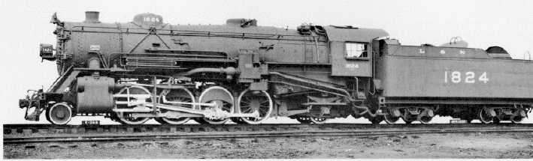

Florida East Coast Chapter, NRHS
P.O. Box 2034
Cocoa, Fl 32923
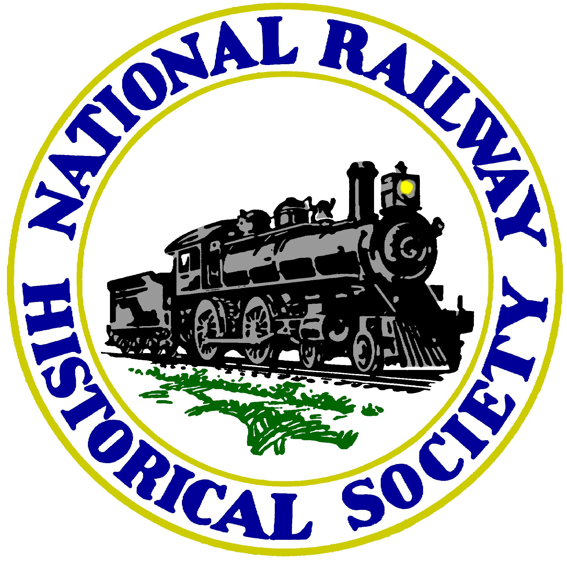

Attention:
Meeting location Changed
See Presidents Message

