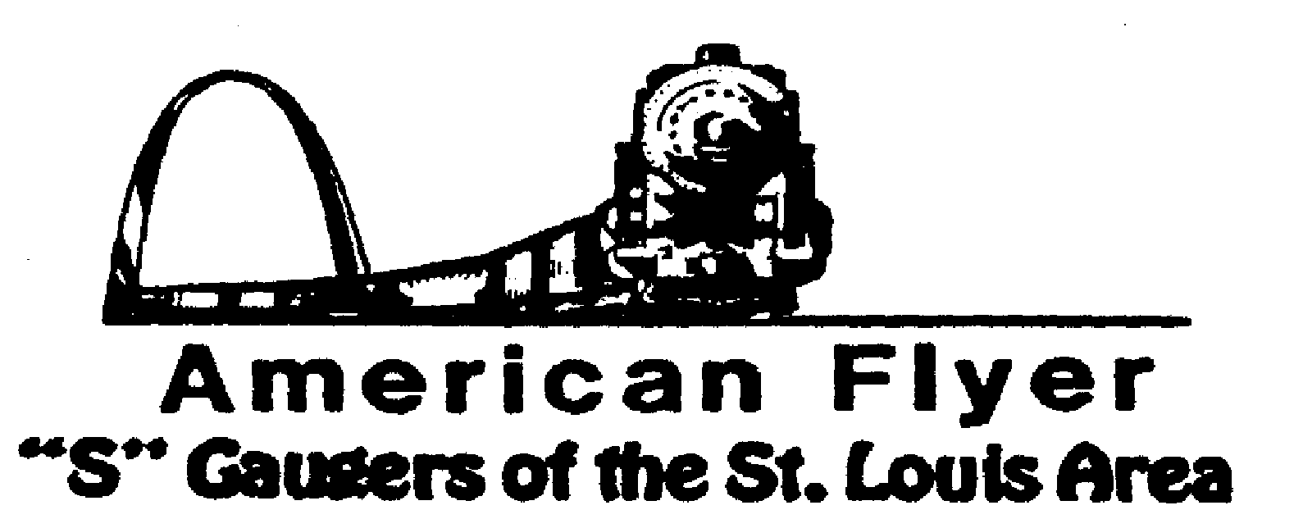

Website: www.trainweb.org/afsgsla/ E-Mail: afsgsla65@gmail.com
______________________________________________________
AFSGSLA NEWSLETTER
September 2022

AFSGSLA Club Events and Related Activities:
.

As with the last several newsletters, we are combining the planned club events and the other related activities. Although we will not necessarily participate in some of the following events as a club, they are included in this somewhat comprehensive listing for your information. We suggest you keep this newsletter for your future reference and attend our club meetings for full details.

Friday, September 9, 2022: AFSGSLA club meeting hosted by Cliff and Gail Saxton. We will meet at his outstanding train and toy collection room, located at 12363 Federal Drive in Des Peres, Missouri. Plan on gathering at our usual time.
September 17, 2022: IT’S BACK!! Boeing Railroad Club Swap Meet, but different for this time. It will be held at the North County Rec Complex on Redman Ave. This is a smaller complex then Queeny so they will not have room for our layout. Also note that this date is different than originally published.
Saturday, September 24, 2022: Pacific Eagles Train Show. 10:00 a.m. to 3:00 p.m. 707 Congress Street, Pacific, Missouri. Admission is $3.00.
Saturday and Sunday, October 8 & 9, 2022: Mississippi Valley N Scalers (MVNS) show at the Kirkwood Community Center, Kirkwood MO. It is anticipated that we will be displaying our sectional layout this year.
Saturday, October 29, 2022: from 9am to 3 pm Halloween Trains at the Library
Grant's View Branch, 9700 Musick Avenue, St. Louis MO 63123, Bring your trains to run, mostly Lionel O
Saturday, November 12, 2022: Dupo Train Show, 9:30am until 2pm. Dupo American Legion Post, Dupo, IL. We are scheduled to display the double helix.
Saturday and Sunday, November 26-27, 2022: Great Train Show, Collinsville Convention center. Our application is currently “pending”, meaning we will not find out for sure until closer to the show.
Saturday, December 3, 2022: Great St. Louis Christmas Train Show and Food Drive. 9:00 am to 3:00 pm, Admission $ 5.00 per person. Immanuel Lutheran School, 9733 Olive Blvd. Olivette, MO 63132. We traditionally display our double helix, but not confirmed yet.
Saturday and Sunday, January 28-29, 2023: Great Train Show, St. Charles convention center. Our application is currently “pending”, meaning we will not find out for sure until closer to the show.
Saturday, February 18, 2023: Pacific Eagles Train Show. 10:00 a.m. to 3:00 p.m. 707 Congress Street, Pacific, Missouri. Admission is $3.00.
March 11, 2023: Boeing Railroad Club swap meet returns to Queeny park.
September 9, 2023: Boeing Railroad Club swap meet at Queeny park.

What’s been happening?

April 22, 2022: Club meeting hosted by Joel Weber. Joel is a new member having moved into the area from Chicago. He has made an impressive start to a new layout. Many of us know Joel and have seen his old layout in connection with previous S Fests.
May 14, 2022: Club meeting hosted by Bob Muehling. We met at Bob’s after the the Imperial train show for lunch and a great meeting. The workmen on Bob’s layout still have not finished painting the bridge.

This and That

St. Louis Lionel Railroad Club – The club has a new home! The club voted to accept an offer from St. Matthias parish for the rental of two former classrooms. Unfortunately, there are dark clouds forming with the archdiocese planning on reducing the number of parishes by about half.
2023 Fall S Fest – At the 2021 S Fest, Chicagoland said they planned to host the 2023 S FEST. No date or location has been received yet.

2022 Fall S Fest – As of now, there is no 2022 S Fest scheduled.

Midwest Money Layout Open House - Sponsored by the Midwest Money Company, on the First Sunday of every month from 11:00 A.M.to 4: P.M. They are located at 5901 Hampton, St. Louis MO just across Holly Hills Street. The layout is rather large, fully developed scenery 3 rail O-Scale layout. This rather large layout may be one of only a very few which can be claimed to be 100% complete. This location is in South St. Louis City, roughly halfway between Chippewa and Gravois

IN MEMORIUM

As many of you already know, Don Heimburger, passed away on June 10, 2022. He was a major force in our hobby, with his vending, manufacturing and publishing business.

Not a member of our club, but a member of TCA who attended most of the swap meets as a vendor, Leroy Rodgers passed away in April. He was known for his name tag of Roy Rodgers on occasion,

Special notice from David Stevens: Dave has had it easy recently, but as you can see, we are hoping to get back to in person club meetings now in 2022. We have had a number of our faithful club members who have volunteered to host future meetings. Although our David Stevens is especially pleased with the excellent response to his recent requests, he tells us that we still need club members to volunteer to host club meeting in the future. He states that if you have not hosted a meeting recently---or ever---please carefully consider doing so. It is a great way to “pay your dues” and it really is not much trouble to host a club meeting (the club pays our host a modest fee to offset expenses for refreshments). We have often said (and our hosts have agreed) that there is no surer way of getting your train room shaped up then hosting a club meeting. David Stevens will help you with the details, if you just contact him at Telephone: 314/ 921-1127 or stevens8128@sbcglobal.net.

Notes from your Co-Coordinators!

TOM SCHNUR
AFSGSLA Co-Coordinator
afsgsla65@gmail.com

RICK ARCHESKI
AFSGSLA Co-Coordinator
rcheski@charter.net

That’s it for now, more later:
GARY MUELLER
AFSGSLA Newsletter Editor
gmatmueller@aol.com

-And remember, “It’s just for the fun of it!”

